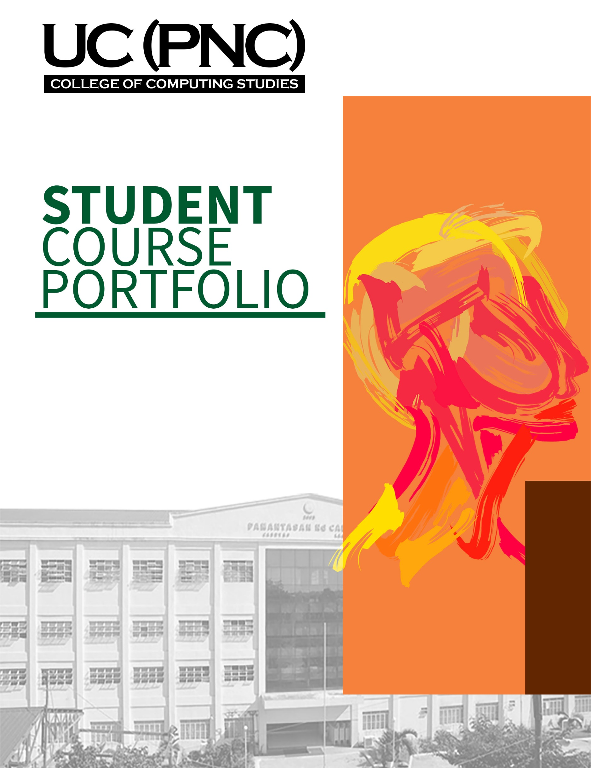­­

CCS106-Social and Professional Issues

A.Y. 2022 – 2023 / 2nd SEMESTER

Asst. Prof. FE L. HABLANIDA

[Section]

#### Living in the IT Era

**Table of Content**

1. Vision/Mission of UC (PnC)
2. PEOs of the Program
3. SOs addressed by the course.
4. OBTLP or Courses Syllabi/Outline
5. Answered Prelim Assessment Tasks (lecture/lab)
6. Learning Reflection
7. Answered Midterm Assessment Tasks (lecture/lab)
8. Learning Reflection
9. Answered Finals Assessment Tasks (lecture/lab)
10. Learning Reflection
11. Overall Course Learning Reflection
12. Suggestions/Recommendation

**VISION**

**A premier institution of higher learning in Region IV, developing globally competitive and value-laden professionals and leaders instrumental to community development and nation-building.**

**MISSION**

**As an institution of higher learning, UC (PnC) is committed to equip individuals with knowledge, skills, and values that will enable them to achieve their professional goals & provide leadership and service for national development.**

**PRELIMENARY**

The two activities we cover in our preliminary are the quiz and the examination. The principal subjects of these two activities are ethical theories and the professional code of ethics. The emphasis of the exam is on measuring ethical understanding.

**ACTIVITY 1: Ethical Theories**

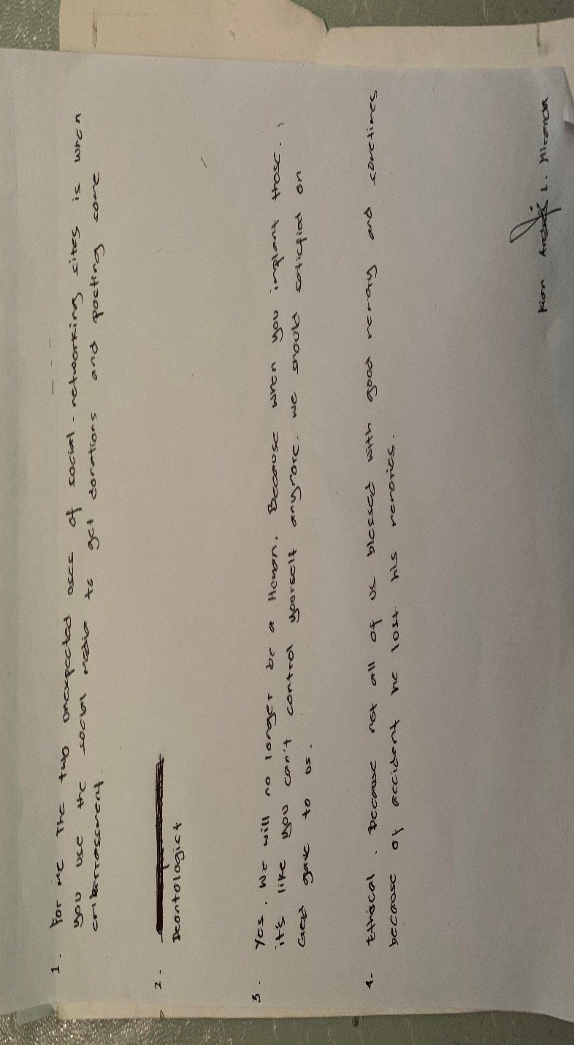

This is our first task, and I received a very poor grade because of pressure, the passage of time, and my failure to anticipate completing it on paper. As a result, I ran out of time and didn't fully comprehend what I was supposed to complete,

**ACTIVITY 2:** **Activity on Professional Code of Ethics**

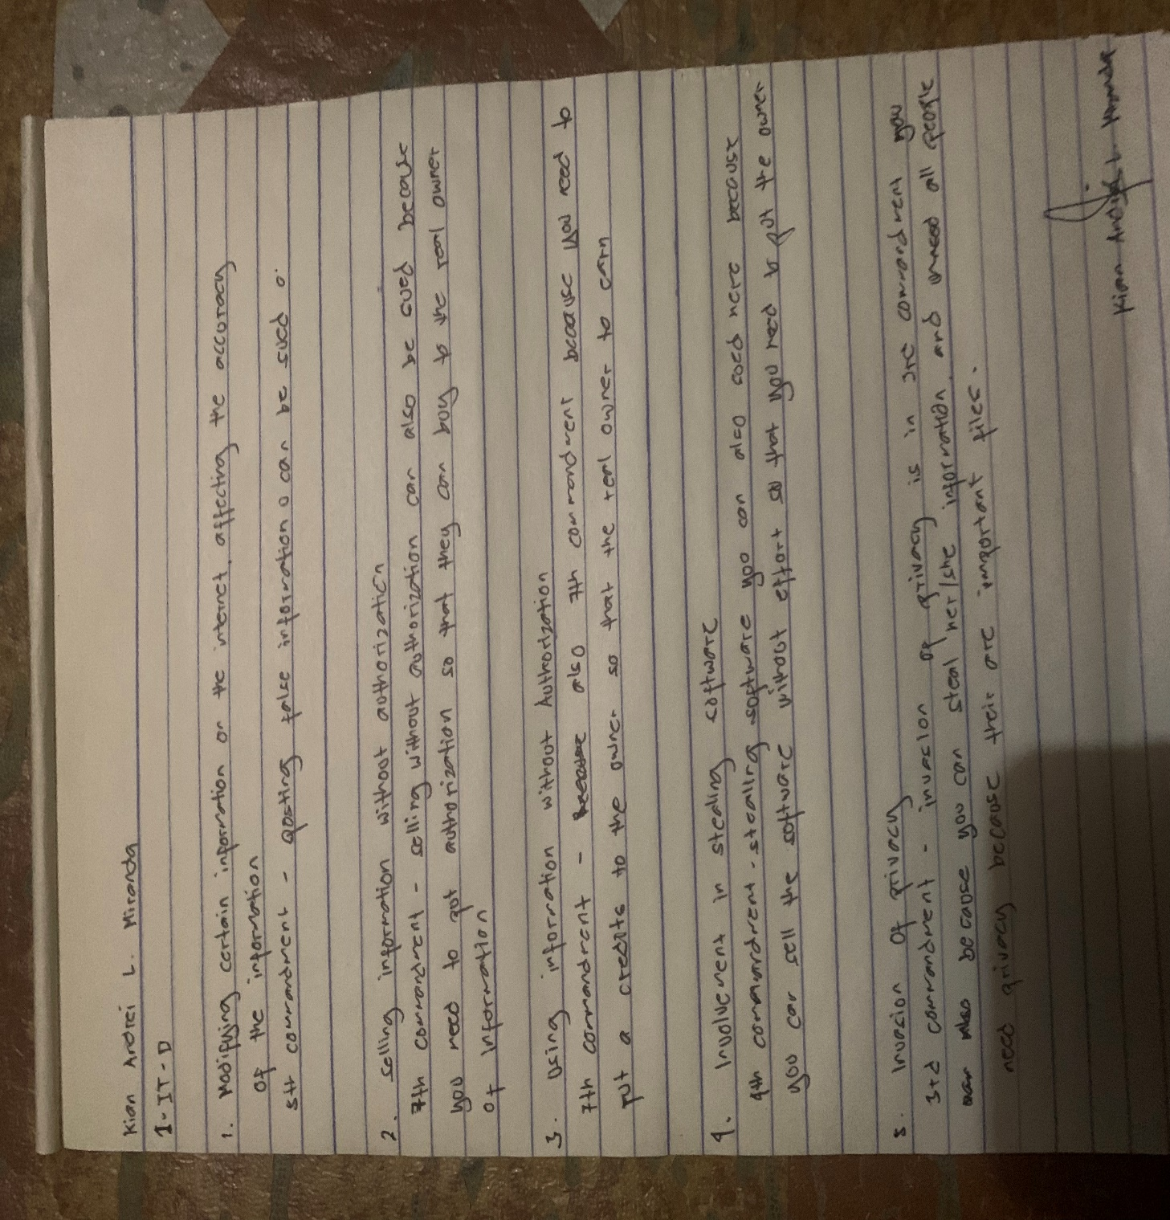

This is our second exercise, and I was able to recover a little and modify a little. Although it wasn't too high, it's still fine because my score went up.

**QUIZ 1: ETHICAL THEORIES**

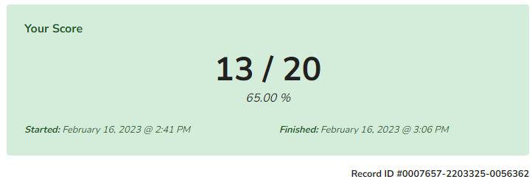

This is our first quiz in this class and I got a 13/20. It's not too low and I know there will be more to it, so I'm thinking I'll do my best.

**PRELIM: EXAMINATION**

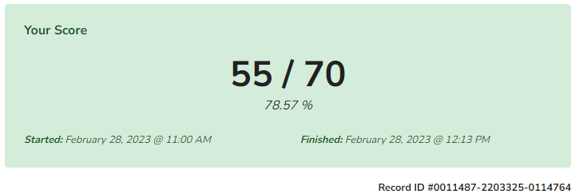

here is my result in the prelim examination and for me my score is okay and I know that I did my best to get a high score and I am happy with the result because I did not fail and I will do my best

**PRELIM LEARNING REFLECTION**

The intensive and demanding nature of this time is brought to memory as I think back on my prelim experience. It was a period of academic difficulty, personal development, and priceless learning. The prelim period was a transforming moment that put my academic prowess, fortitude, and time management talents to the test. It showed me the value of tenacity, teamwork, introspection, and preserving a proper balance. My academic trajectory and beyond will be guided by the lessons I learnt throughout the prelim period, preparing me for upcoming possibilities and challenges.

**MIDTERM**

Our midterms consist of a test, two quizzes, and a reading assignment. Intellectual property, cybercrime law, and the impact of technology on privacy and freedom of expression are the main topics of discussion. The two exams examine the legal ramifications of cybercrime and the impact of technology on privacy. The midterm covers all three subjects.

**ACTIVITY 1: Activity on Cybercrime Law**

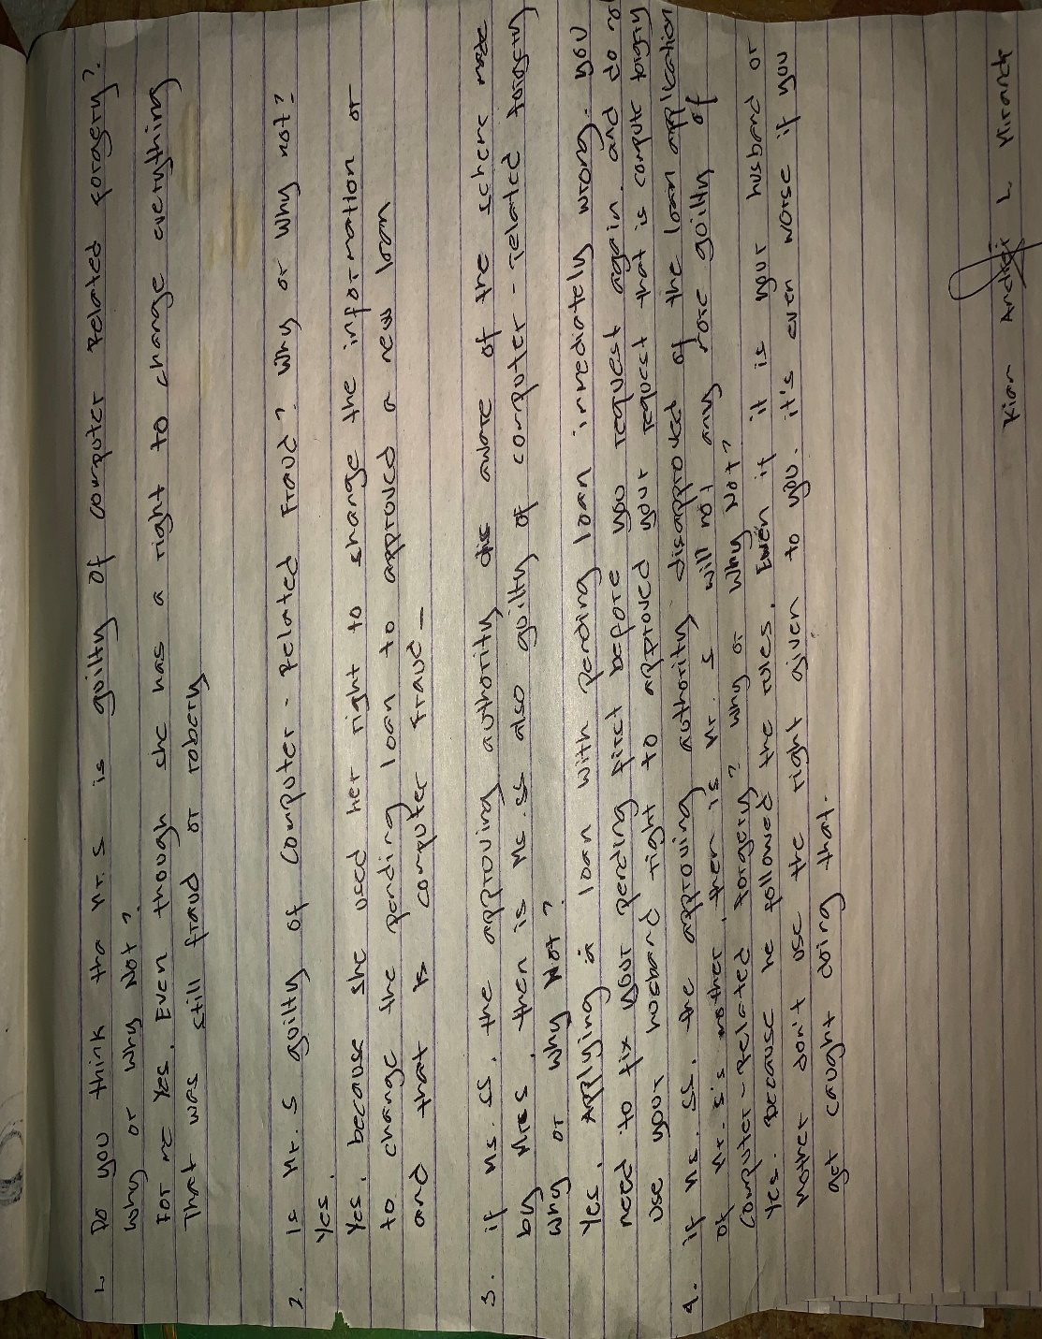

This is our first activity in the midterm and I only got the right score because I didn't answer very well due to time pressure.

**ACTIVITY 2: IMPACT OF TECHNOLOGY IN PRIVACY**

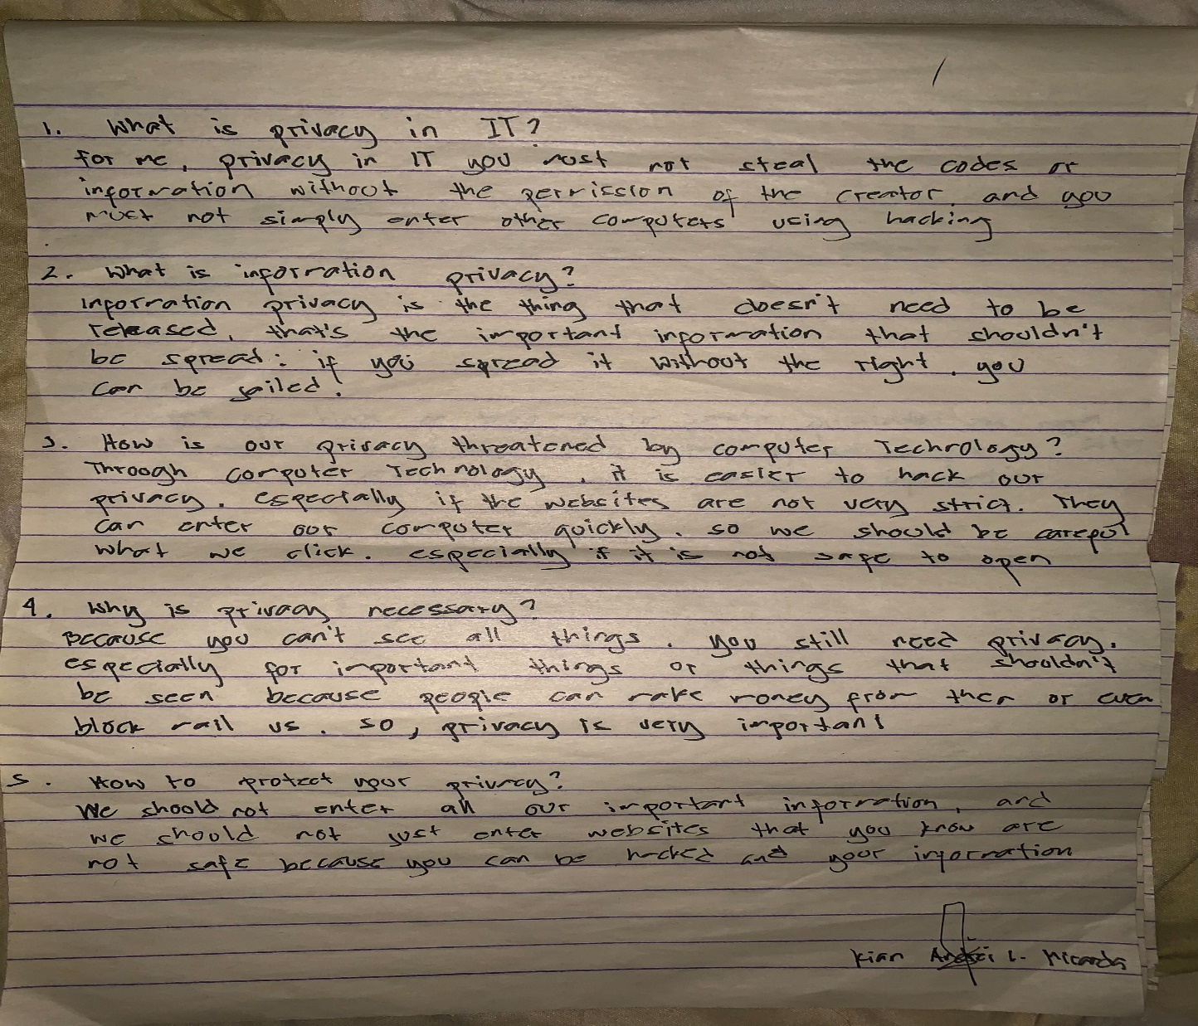

This is our second activity, and I answered everything. I'm getting used to the pressure of time, and I'm happy. I did it right on time, and it's okay even if I got the score right; the important thing is that I was able to work.

**ACTIVITY 3: Activity on Freedom of Expression and Intellectual Property**

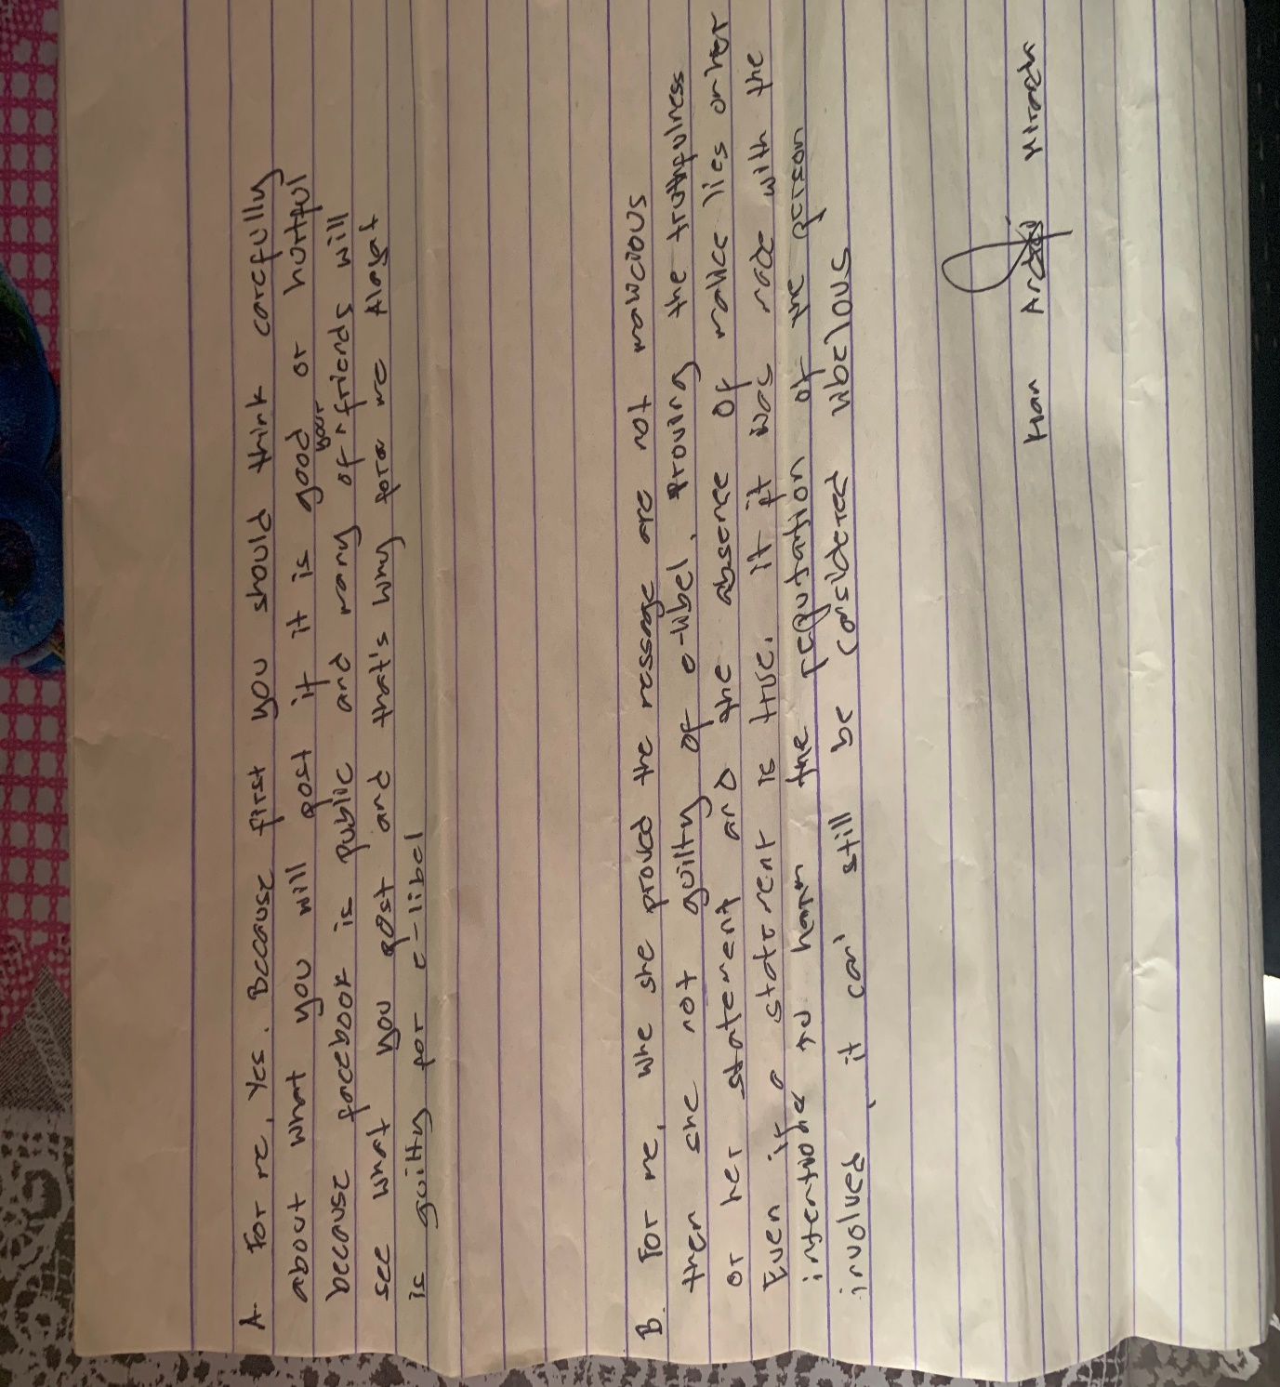

I am happy because I was able to pass again on time and the score was just right and I will do my best for the other acts

**QUIZ 1: CYBERCRIME LAW**

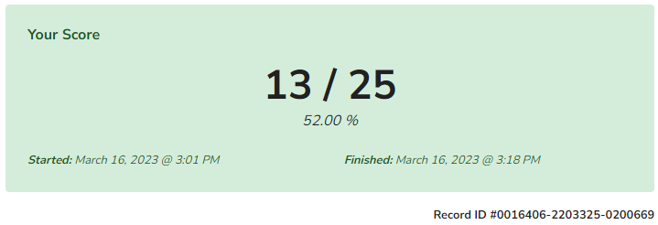

This is our first midterm quiz and I'm disappointed because I got a low score, but it didn't discourage me, I just need to improve on this in the next quiz.

**QUIZ 2: IMPACT OF TECHNOLOGY ON PRIVACY**

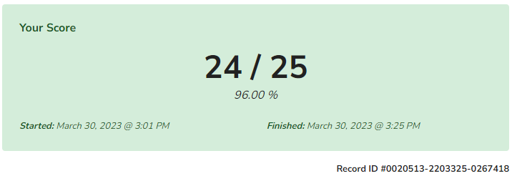

Here is our second quiz, I said in the first quiz that I need to make up, so I checked my answers and reviewed so that I don't get a low score again

**MIDTERM: EXAMINATION**

**NO RESULT**

We are all eager to discover the outcomes of our in-person midterm exam. I took careful to review and recall every piece of critical guidance provided by my professor, so even though the results aren't show yet, I am confident in my performance because I do my best to review all lesson that teach to us.

**MIDTERM LEARNING REFLECTION**

As I consider my experiences throughout the midterm period, I feel a feeling of development, advancement, and self-discovery. A key turning point in my academic career, the midterm period gave me the chance to assess my abilities, knowledge, and overall performance. I was able to assess my development during the midterm period, pinpoint areas for improvement, and recognize successes. It placed a strong emphasis on the value of flexibility, time management, seeking support, and personal development. With the help of these thoughts, I am better equipped to handle upcoming academic problems and keep moving forward in my learning and development.

**FINALS**

Eight exercises make up our finals, including six of our own creations and a quiz. Laws that expressly handle defamatory claims made through electronic channels, such as the internet, social media platforms, or email, are referred to as "e-libel laws," sometimes known as "cyber libel" or "online libel." The activities are centered on e-commerce law, access devices regulating act, freedom of expression and E-Libel Law, fundamentals of data protection, extent of ICT professionals' liability, and a final lengthy quiz on the impacts of E-Libel Law. Final exams are required for all themes, and protection refers to the policies and legislation created to safeguard the privacy and security of personal information.

**Special Assignment**

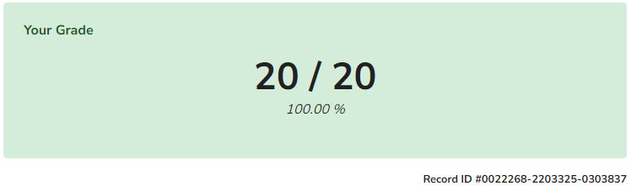

I'm happy because for me, these points are a big deal, and the bubble run is a lot of fun. Then there are plus points, so I don't regret joining because it's worth it.

##### **Activity 1: Activity on Freedom of Expression and E-Libel Law**

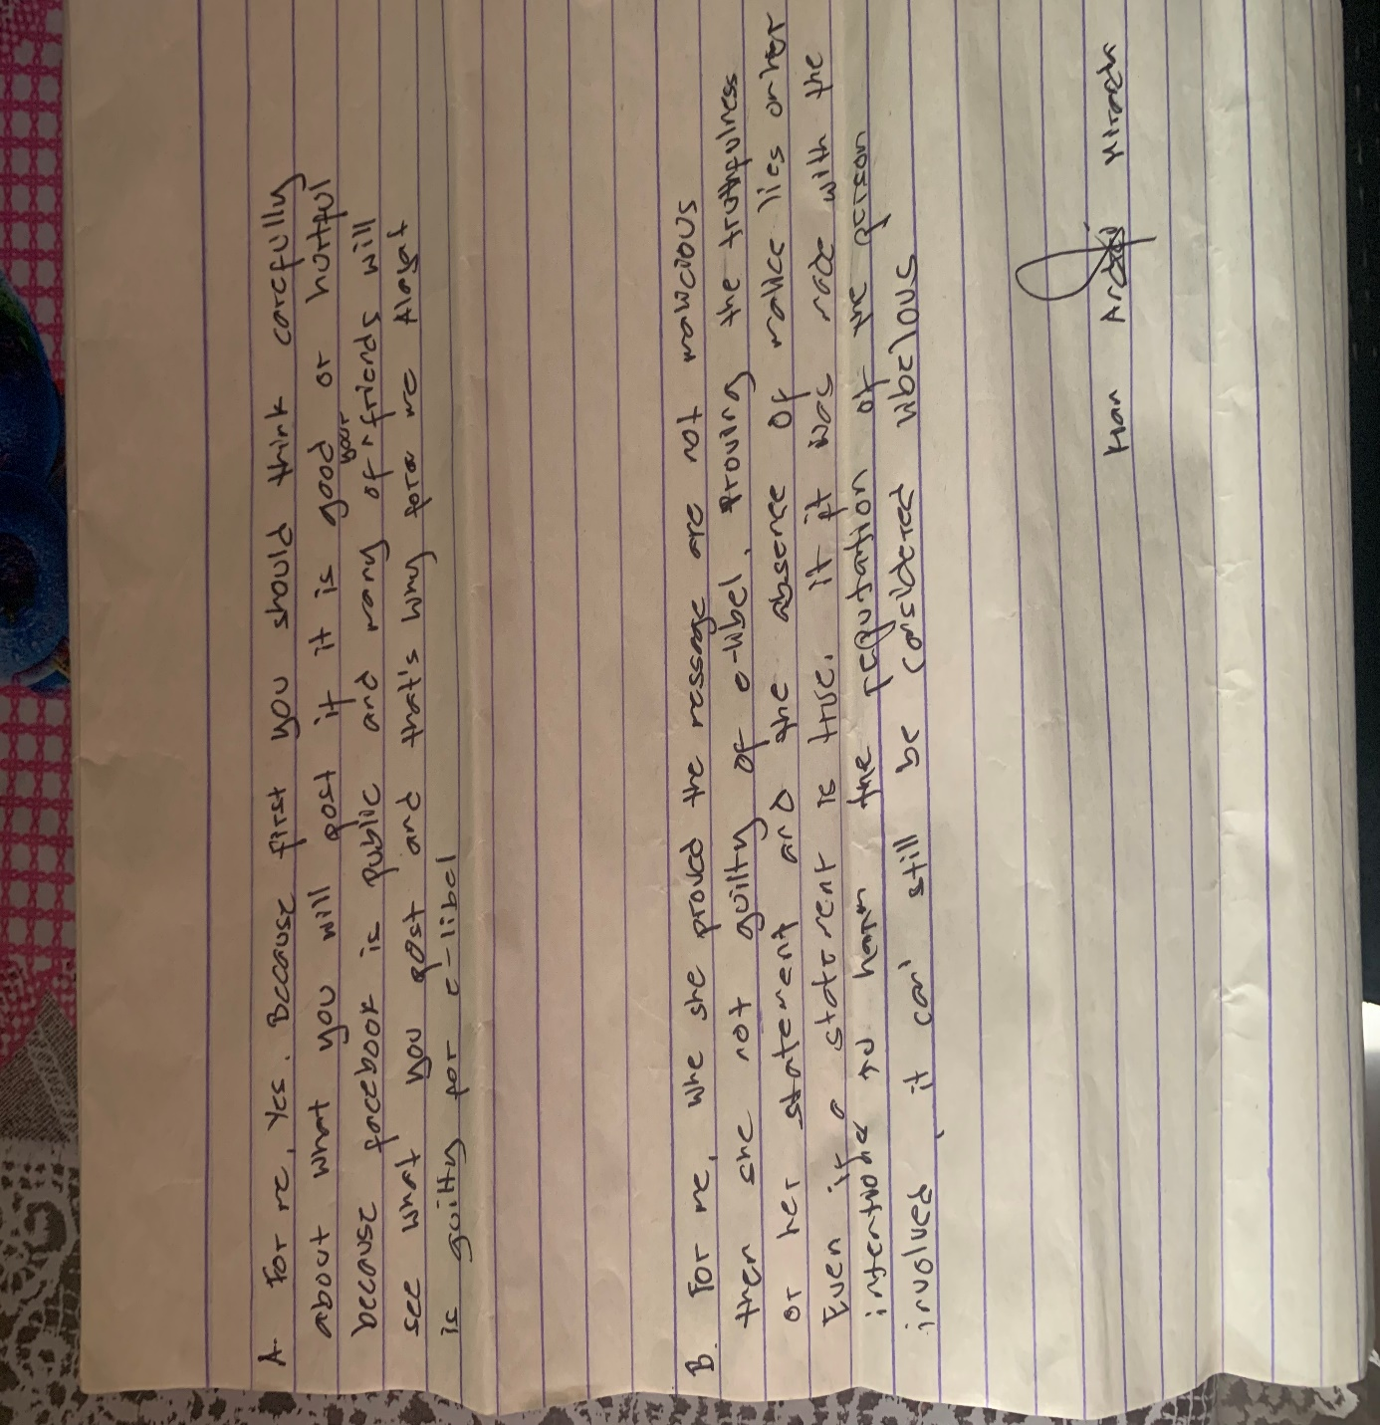

**Activity 2: Activity on Essentials of Data Protection**

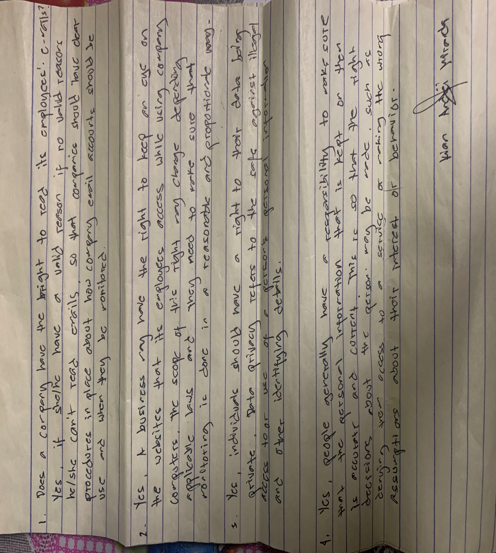

**Activity 3: Extent of Liability of the ICT Professionals**

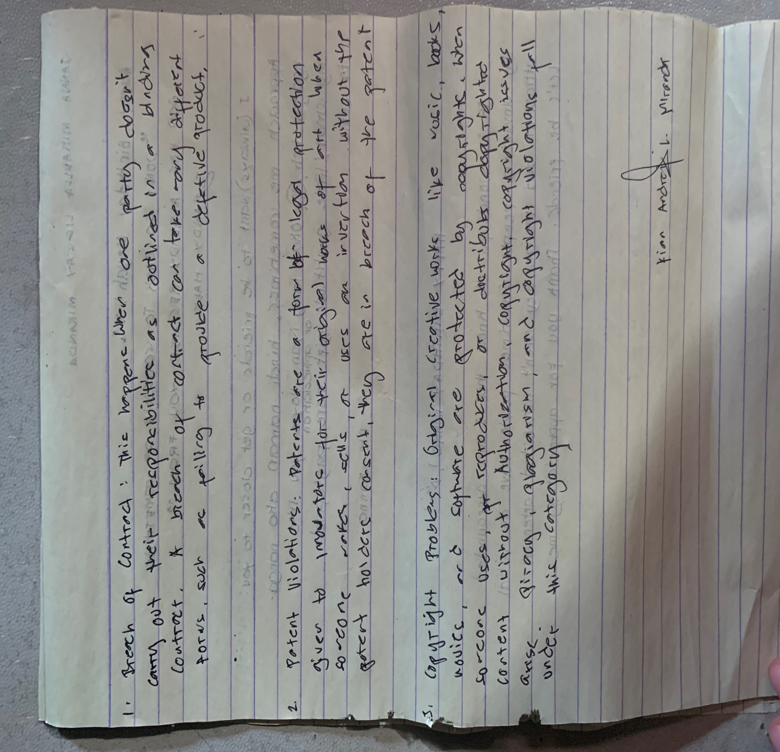

**Activity 4: E-Commerce Law**

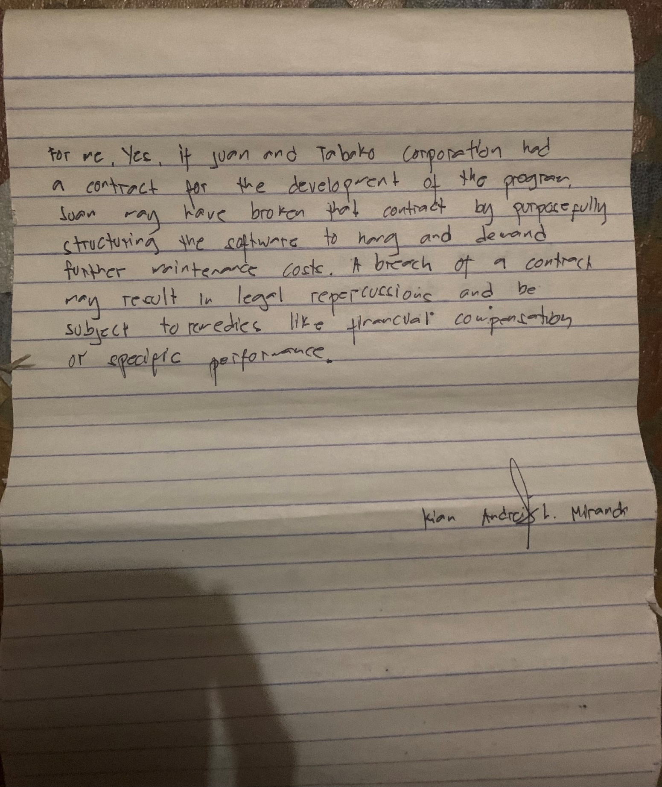

**Activity 5: Access Devices Regulation Act**

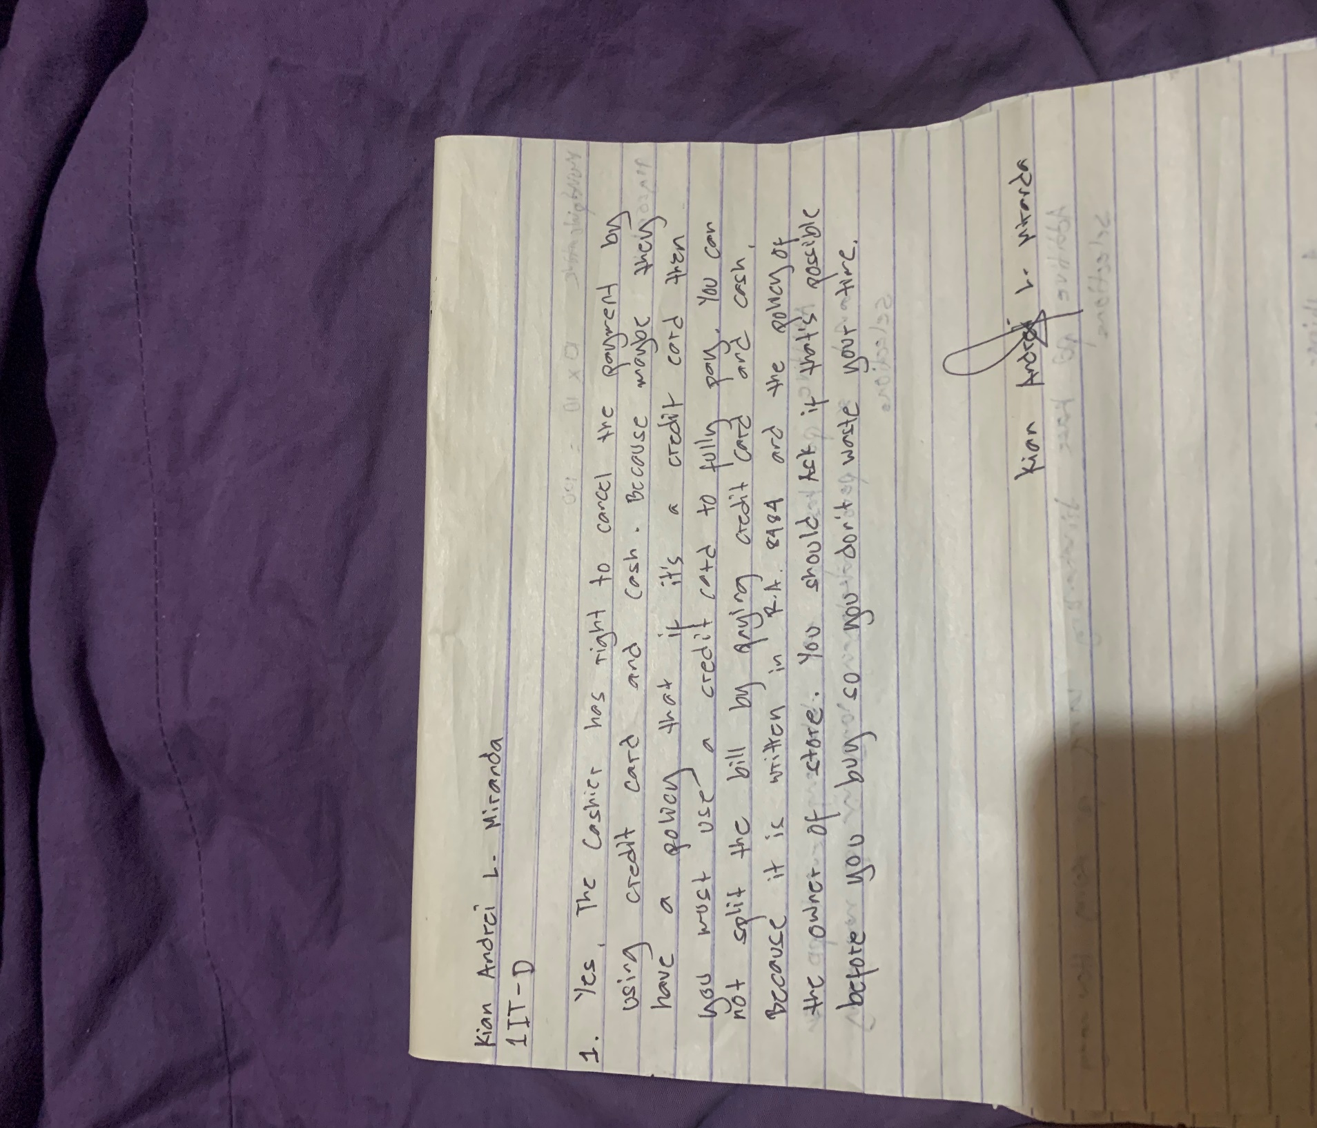

**Activity 6: President’s Hour Reflection**

**Finals Long Quiz**

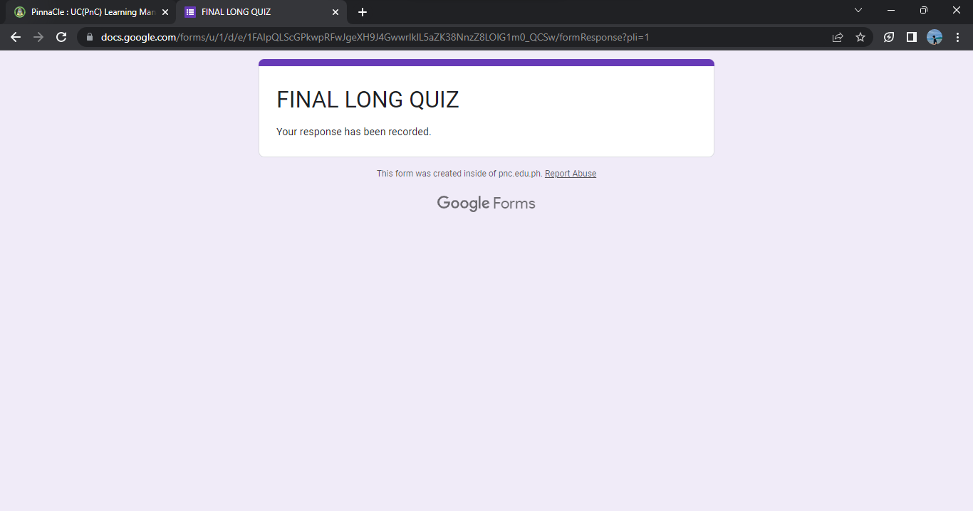

**Finals Group Assessment Task**

**FINALS LEARNING REFLECTION**

A range of emotions fills my heart as I think back on my finals experience. My diligence, perseverance, and acquisition of information throughout the course of the semester culminated during finals week. The finals period was marked by intense attention, introspection, and personal development. It made me feel physically, mentally, and emotionally challenged. I learned the value of resilience, time management, self-care, teamwork, and reflection over the finals period. These lessons will continue to serve as a roadmap for me as I pursue academic goals and beyond, enabling me to tackle new difficulties with grit and a growth attitude.